Assignment 04:

1. Display the PNAME and COLOR from the P table for the CITY=”London”.

SELECT pname, color FROM p WHERE city = ‘London’;
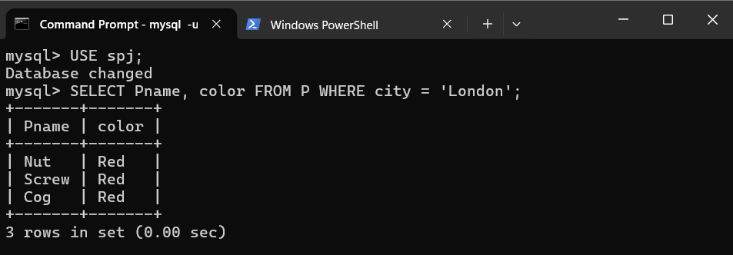

2. Display all the Suppliers from London.

SELECT * FROM S WHERE city = ‘London’;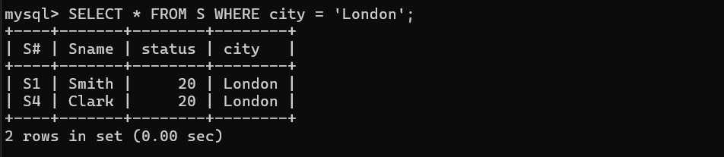

3. Display all the Suppliers from Paris or Athens.
SELECT * FROM S WHERE city IN(‘Paris’, ‘Athens’);
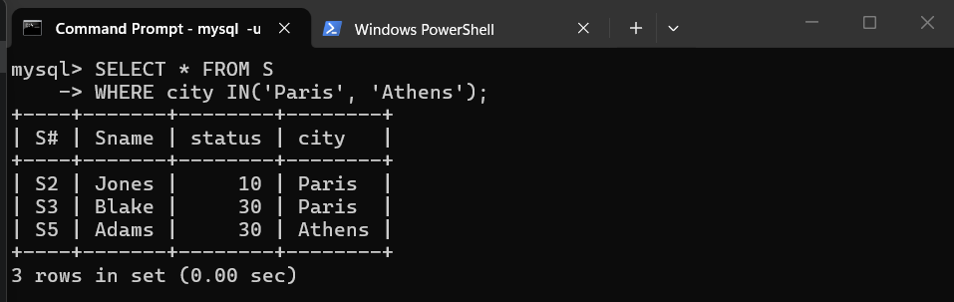

4. Display all the Jobs in Athens.
SELECT * FROM J WHERE city = ‘Athens’;
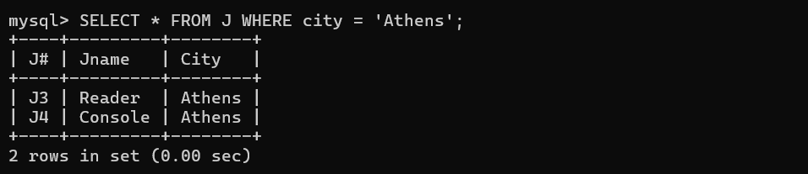

5. Display all the Part names with the weight between 12 and 14 (inclusive of both).
SELECT Pname FROM P WHERE weight BETWEEN 12 AND 14;
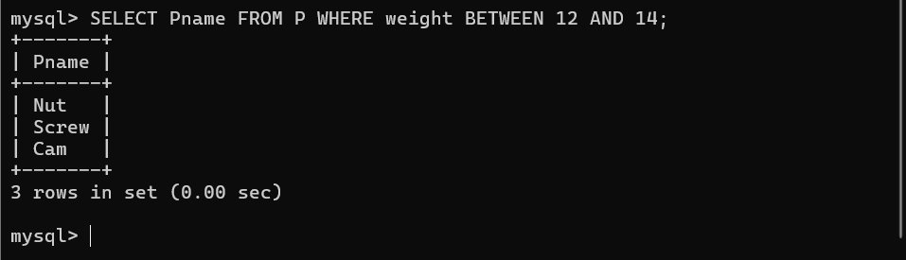

6. Display all the Suppliers with a Status greater than or equal to 20.
SELECT * FROM S WHERE status >= 20;
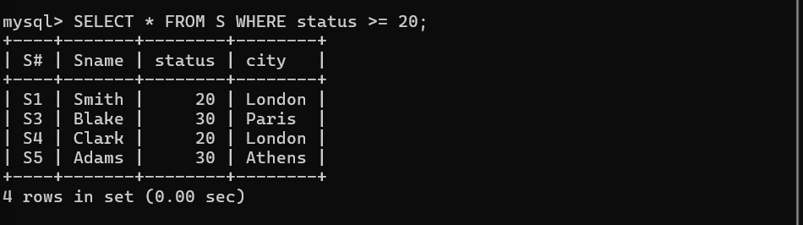

7. Display all the Suppliers except the Suppliers from London.
SELECT * FROM S WHERE city <> ‘London’;
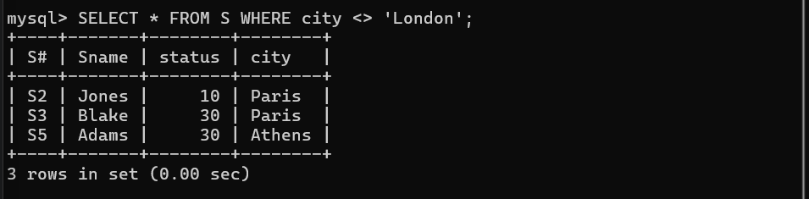

8. Display only the Cities from where the Suppliers come from.
SELECT DISTINCT city FROM S;
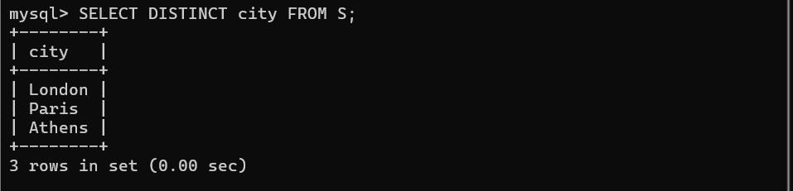

9. Display the Supplier table in the descending order of CITY.
SELECT * FROM S ORDER BY city DESC;
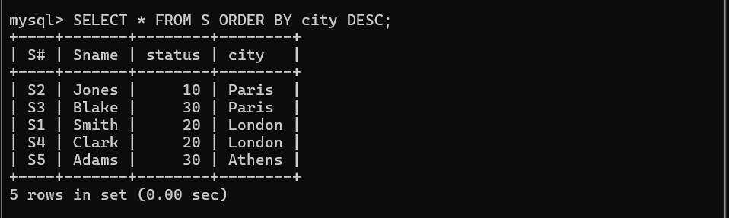

10. Display the Part Table in the ascending order of CITY and within the city in the ascending order of Part names.
SELECT * FROM P ORDER BY city,Pname ASC;

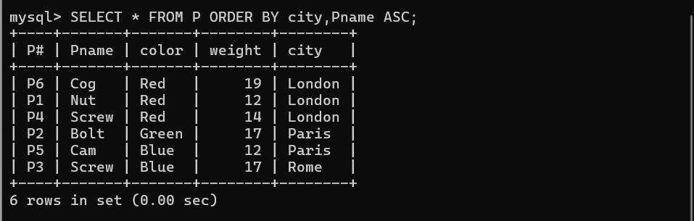

11. Display all the Suppliers with a status between 10 and 20.
SELECT * FROM S WHERE status BETWEEN 10 AND 20;

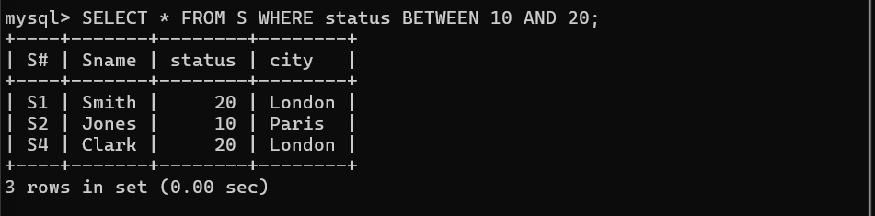

12. Display all the Parts and their Weight, which are not in the range of 10 and 15.
SELECT Pname, weight FROM P WHERE weight NOT BETWEEN 10 AND 15;



